**Question set 1**

Q1) Who is the senior most employee based on job title?



Q2) Which countries have the most invoices?

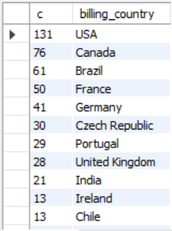

Q3)What are top 3 values of total invoices?

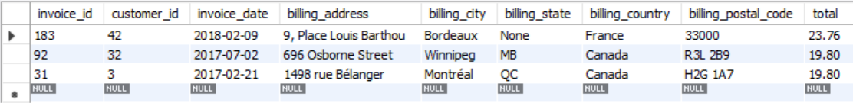

Q4)Which city has the best customers? We would like to hold a festival in the city with the most money. Write a query that returns one city that has the highest sum of invoice totals. Return both city name and sum of all invoice totals.



Q5) Write a query to return the customer who has spent the most money

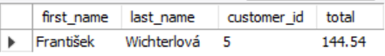

**Question Set 2:**

Q1) Write query to return email, first name, last name, and genre of all rock music listeners. Return list ordered alphabetically by email starting from A.

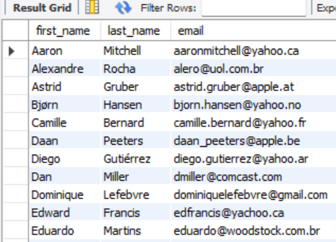

Q2) Return the artists who have written the most rock music in our dataset. Write a query that returns artist name and total track counts of top 10 rock bands.

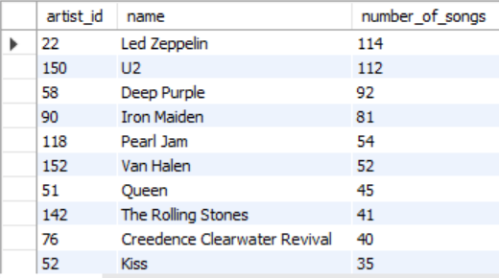

Q3) Return all the track names that have song length longer than average song length. Return name and milliseconds for each track. Order by song length with longest songs listed first

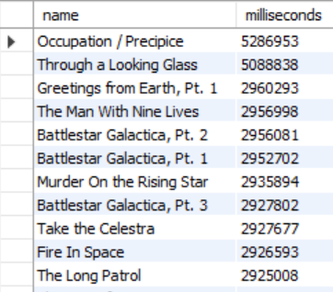

**Question set 3:**

Q1) How much amount spent by each customer on artists?

Write query to return customer name, artist name and total spent

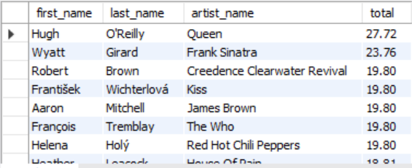

Q2) Find out most popular genre for each country. We determine most popular genre as genre with highest number of purchases. Write a query that returns each country along with top genre. For countries where maximum number of purchases is shared, return all genres.

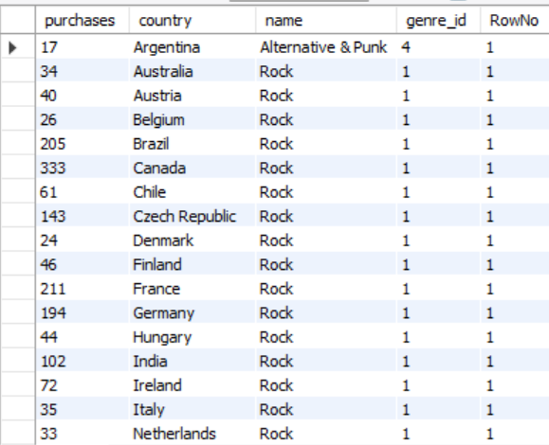

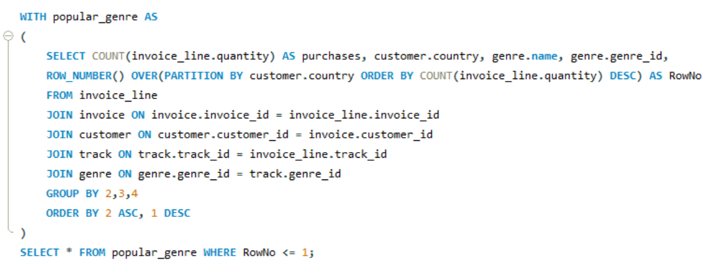

Q3) Write a query that determines the customer that has spent the most on music for each country.

Write a query that returns the country along with the top customer and how much they spent.

For countries where the top amount spent is shared, provide all customers who spent this amount.

